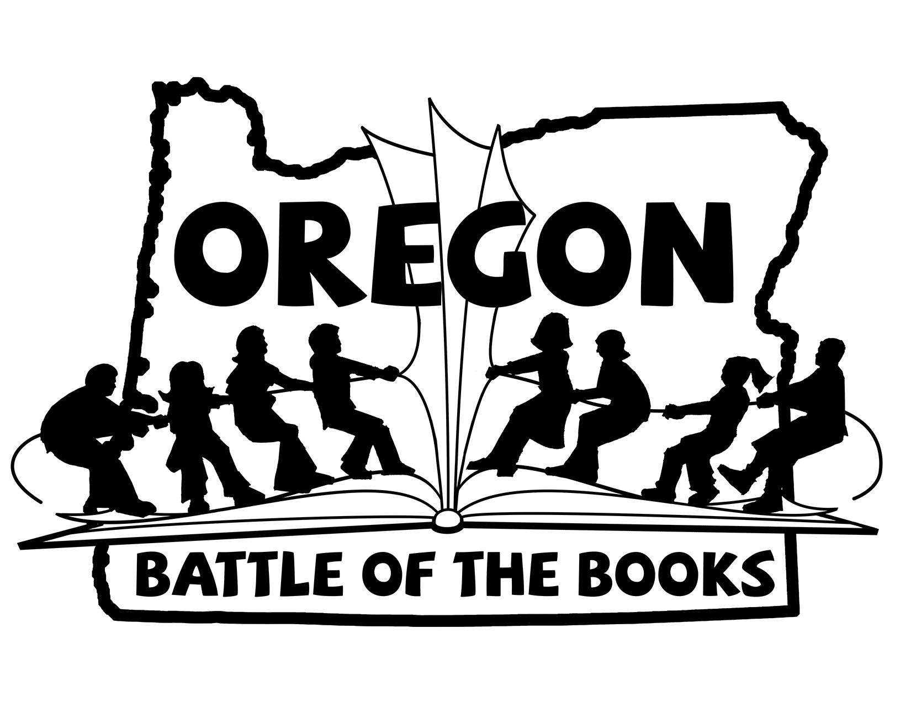
2018-2019
6th to 8th Grade Division
- Absolutely Truly by Heather Vogel Frederick
- Avenging the Owl by Melissa Hart
- The Body in the Woods by April Henry
- Cryptid Hunters by Roland Smith
- Doll Bones by Holly Black
- The Gauntlet by Karuna Riazi
- Ghost by Jason Reynolds
- I Will Always Write Back by Caitlin Alifirenka & Martin Ganda
- The Luck Uglies by Paul Durham
- My Seventh-Grade Life in Tights by Brooks Benjamin
- Restart by Gordon Korman
- Revenge of the Witch by Joseph Delaney
- Small as an Elephant by Jennifer Richard Jacobson
- The Sword of Summer by Rick Riordan
- The Wishing Spell by Chris Colfer
- Wolf Hollow by Lauren Wolk

